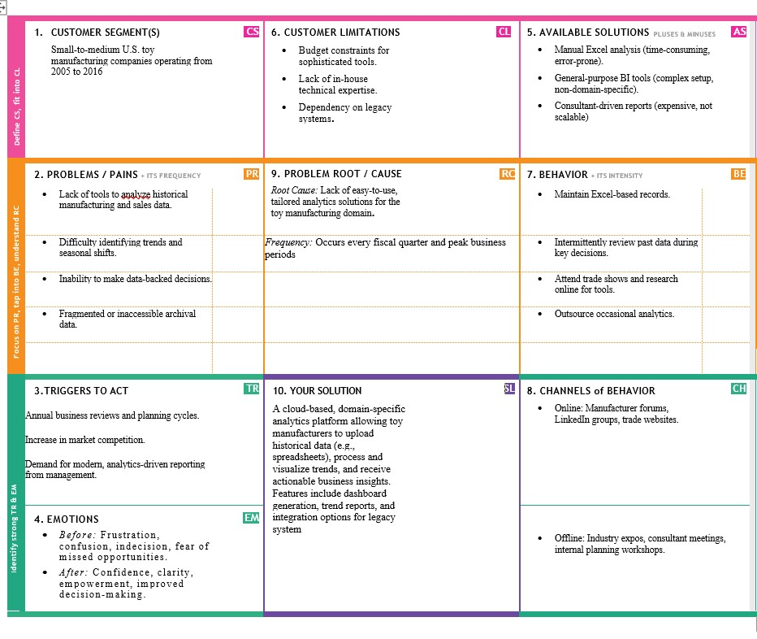

PROJECT DESIGN PHASE

PROBLEM SOLUTION
-
FIT

Date

FEB 2026

Team ID

LTVIP2026TMIDS37677

Project Name

T
oyCraft

tales: tableau's vision into
toy manufacturer data

Maximum Marks

2

Marks

P
roblem
solution
fi
t

